Description
Novel C5 Resins
NEVTAC® T950 & T1000

NEVTAC® T950 and T1000 are thermoplastic, low molecular weight hydrocarbon resins made through the
polymerization of mixed DCPD and aliphatic monomers. Primary uses include pressure-sensitive adhesives,
hot melt adhesives, coatings and rubber compounding. They serve as functional alternatives to traditional
piperylene-based and aromatic-modified C5 resins. These resins offer a strong balance of tack, adhesion, co-
hesion, along with good heat resistance, broad compatibility and solubility.

Applications | Compatible Systems | Features
Hot Melt | SBC (SBS, SIS, SEBS) | Tack Build
Pressure Sensitive Adhesives | EVA | Hydrophobic
Tire and Rubber | Polyolefins | Resistant to Acids and Alkalis
Elastomeric Sealants | Butadiene Rubber | Adhesion Promoter
Water resistant coatings | Butyl Rubber | Good Compatibility
Asphalt Modification | Natural Rubber | Low Molecular Weight

Typical Properties
Properties | Test Method | NEVTAC® 100 | Super  NEVTAC® 99 | NEVTAC®  T950 | NEVTAC® T1000
Basic Chemistry | - | Piperylene | Aromatic modified Piperylene | Modified DCPD | Modified DCPD
Softening Point, R&B °C | ASTM E28 | 100 | 95 ± 3 | 92 ± 3 | 100 ± 5
Gardner Color  (50% in Solvent) | ASTM D1544 | 3.5 | 4.5 | 9.0 | 9.0
Specific Gravity @ 25 °C | ASTM D71 | 0.97 | 0.97 | 1.08 | 1.08
Viscosity Brookfield, cps  140 °C  160 °C  180 °C | ASTM D3236 | 6,050  1,300  400 | 3,700  860  290 | 2,700  600  200 | 7,300  1,300  400
Molecular Weight  Mn  Mw | ASTM D5296 | 1,150  2,800 | 1,000  2,300 | 390  800 | 390  800
Appearance | Visual | Pale yellow pellets | Pale yellow pellets | Yellow flakes | Yellow flakes

*Typical properties are not constructed as specifications.

Novel C5 Resins
NEVTAC® T950 & T1000

Function | Component | SIS PSA | SBS PSA
SIS Elastomer | Kraton D-1161 | 17.5 | /
SBS Elastomer | Kraton D-1101 | / | 10
Tackifier | NEVTAC® T1000  NEVTAC® 100  Super NEVTAC® 99 | 26.5 | 25
Oil | Calsol 5550 | 6 | 15
Antioxidant | BNX 1010 | 0.25 | 0.25
Solvent | Toluene | 50 | 50
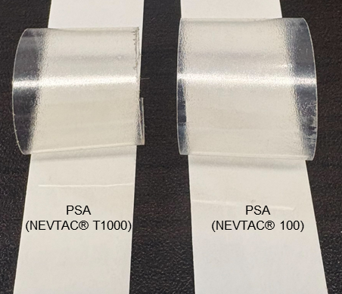
Performance in Pressure Sensitive Adhesives
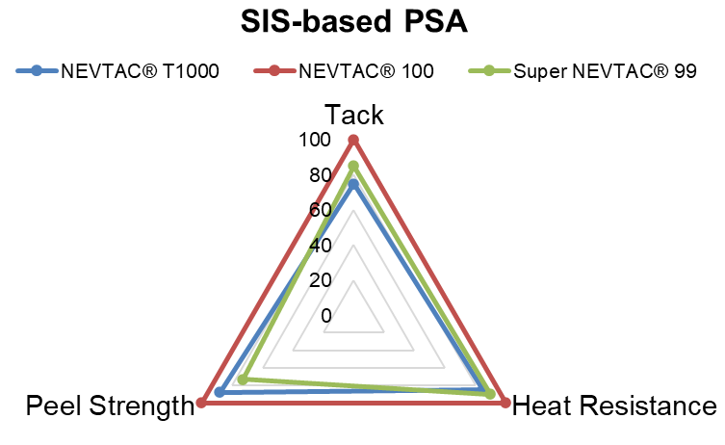
*Score displayed on charts was indexed to NEVTAC® 100 as a benchmark.
Performance of NEVTAC® T1000 was observed in a SIS system. Tack, heat resistance and peel strength all performed comparable to a piperylene-based C5 Resin.
Performance of NEVTAC® T1000 was observed in a SBS system. Tack, heat resistance and peel strength all performed significantly better compared to a piperylene-based C5 Resin.
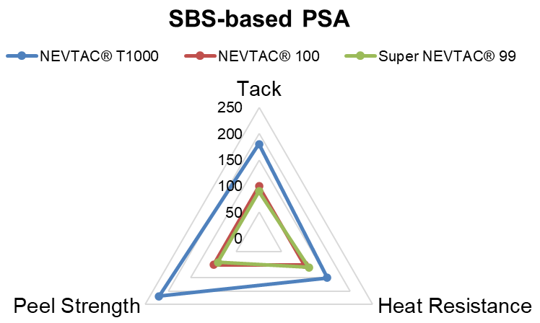
Performance of NEVTAC® T1000 was observed in both SBS and SIS systems. In the SBS system, tack, heat resistance, and peel strength showed significant improvement compared to a piperylene-based C5 resin. In the SIS system, these properties performed comparably to the piperylene-based C5 resin.

Performance in Hot Melt Adhesives
Compatibility (Cloud Points) °C | NEVTAC® 100 | Super NEVTAC® 99 | NEVTAC® T1000
Elvax 40 (40% VA) | >170 | >170 | >170
Elvax 150 (33% VA) | 160 | 135 | 105
Elvax 250 (28% VA) | 125 | 95 | N/A
Elvax 410 (18% VA) | 60 | 60 | 55

*NEVTAC® T1000 showed comparable compatibility with EVA and Wax.

Compatibility is evaluated using an EVA/resin/wax ratio of 1:1:1. The cloud point test shows the temperature at which the system exhibits cloudiness; the lower number indicates better compatibility between the resin and the EVA/wax system.
April 2026

